Cloud Watch

Amazon Cloud Watch is a monitoring and observability service provided by AWS (Amazon Web Services).
It allows you to monitor your AWS resources, applications, and services in real time.
Cloud Watch helps you collect and track metrics, logs, events, and alarms, making it easier to gain visibility into system performance and operational health.
Cloud Watch is used to:
- Monitor system performance (CPU, memory, network, etc.)
- Track custom application metrics
- Set alarms to notify you about issues
- Automatically respond to system changes
- Analyze logs for troubleshooting
- Gain insights into usage and optimize costs

Example Use Cases
- Monitor EC2 Instance Performance
  - Track CPU, disk, and network usage
- Trigger Auto-Scaling
  - Automatically scale EC2 instances when CPU usage is high
- Error Tracking
  - Collect and search application logs for error messages
- Security Monitoring
  - Detect unauthorized access by monitoring login attempts in logs
- Cost Optimization
  - Use dashboards to track underused resources

Key Features of Cloud Watch
Feature | Description
Metrics | Automatically collects metrics from AWS services like EC2, RDS, Lambda, etc.
Alarms | Set thresholds on metrics to send notifications or trigger actions (like auto-scaling).
Logs | Collects, stores, and analyzes log files from EC2, Lambda, CloudTrail, etc.
Dashboards | Visualize metrics using customizable dashboards. (Add various widgets (graphs, numbers, gauges, text) to display key performance indicators (KPIs) and operational health metrics)
Events (now part of EventBridge) | Respond to changes in your environment (e.g., instance stopped, deployment started).
Insights | Use Log Insights for querying and analyzing log data efficiently.
Anomaly Detection | Uses machine learning to detect unusual patterns in your metrics.

Let’s work with Cloud Watch practically

In order to work with the cloud watch, first we have to install Cloud Watch agent using SSM.
To work with SSM we have to create a role by attaching some policies to it.
Now create an EC2 instance using the above role so that it can acts as agent machine.

Step1: Create a Role and add suitable SSM, cloud watch policies to this role.
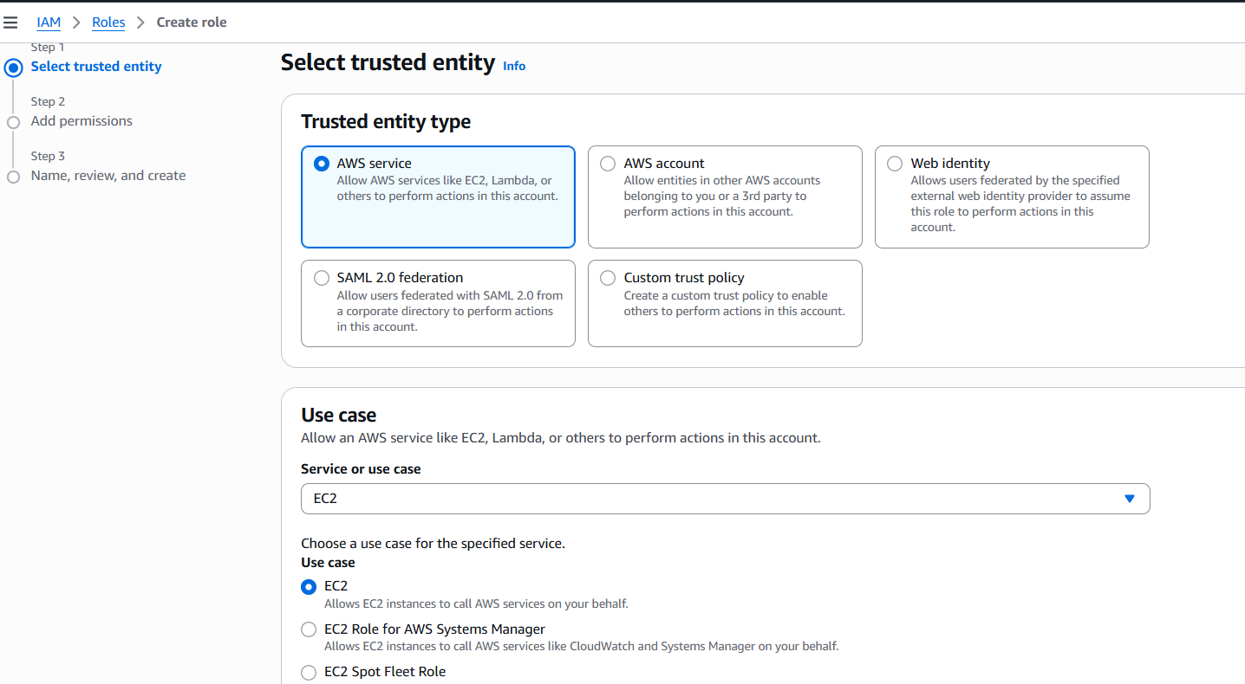

Policy1: AmazonEC2RoleforSSM
Policy2: CloudWatchAgentAdminPolicy
Policy3: CloudWatchAgentServerPolicy

Add the above three policy’s to the role.
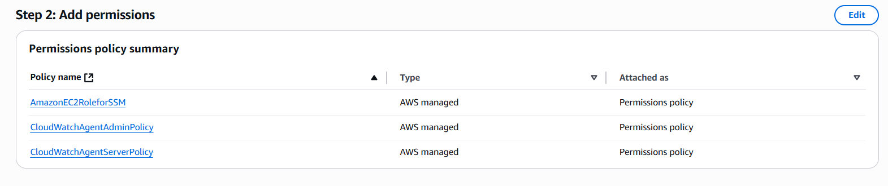
Fig: Three policies were added to the role
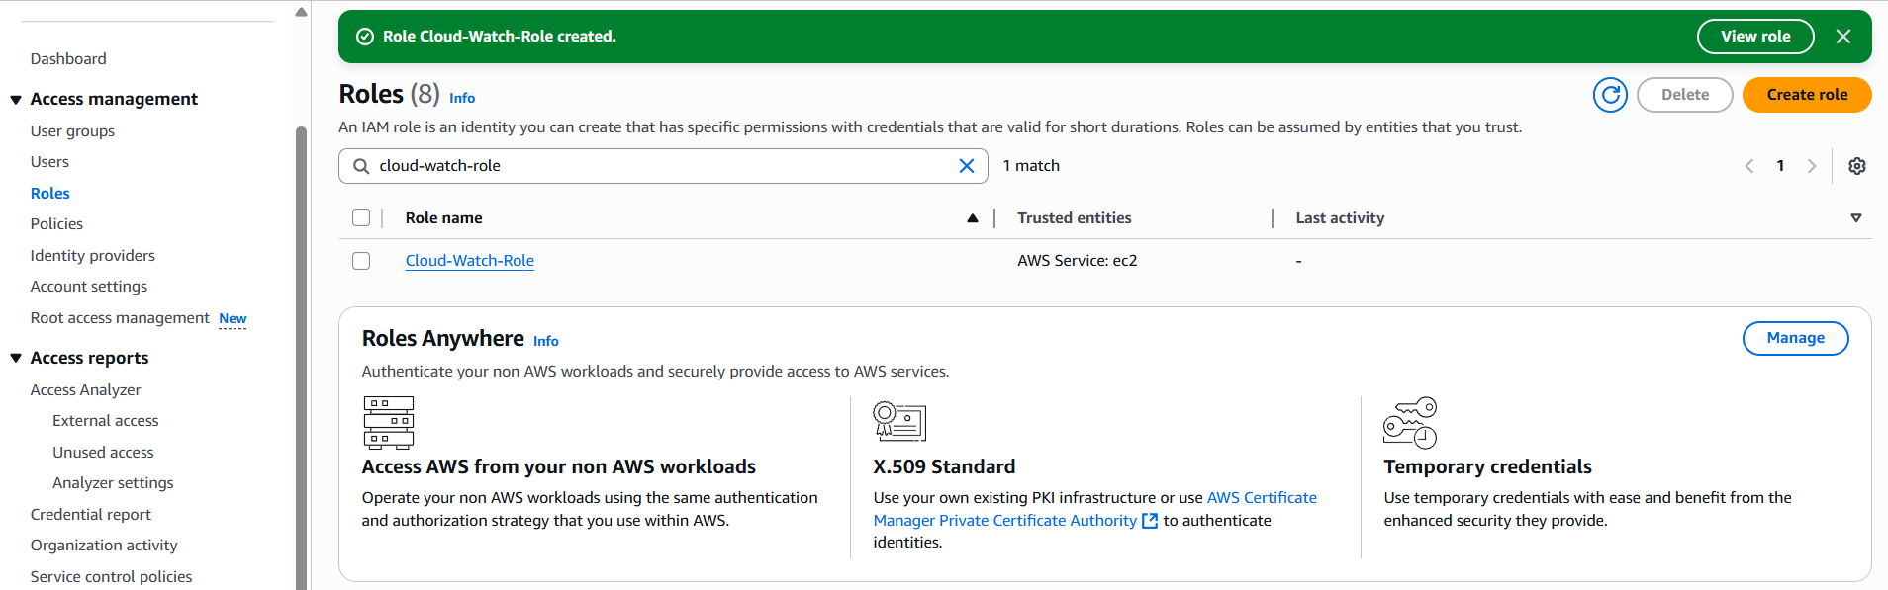
Fig: Role (Cloud-Watch-Role) is created successfully.

Step2: Create a windows EC2 instance, while creating it attach the above role to it.

